**­­­**

Class 7

**Lecture 28**

**MS Access-**

**Adding Data**

**MS Access**



**Lab Objectives:**

* Data Types.
* Adding Data to existing Table.

**Data Types**

Every field in a table has properties and these properties define the field's characteristics and behavior. The most important property for a field is its data type. A field's data type determines what kind of data it can store. MS Access supports different types of data, each with a specific purpose.

* The data type determines the kind of the values that users can store in any given field.
* Each field can store data consisting of only a single data type.

Here are some of the most common data types you will find used in a typical Microsoft Access database.

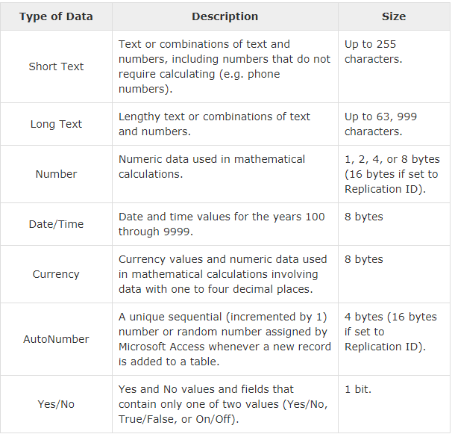

**Add Data to a Table**

There are many ways of adding data to an Access 2016 table. You can use a form, import from an external file, use SQL, and you can enter data directly into the table.

**Add Records Directly into Datasheet View**

This is probably the most obvious way to enter data into a database. Just open up the table and start typing.

Open the Genres table in Datasheet View and enter the following data:

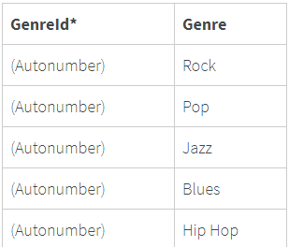

No need to enter anything in the GenreId field. It's an Autonumber field, which means Access will populate it automatically.

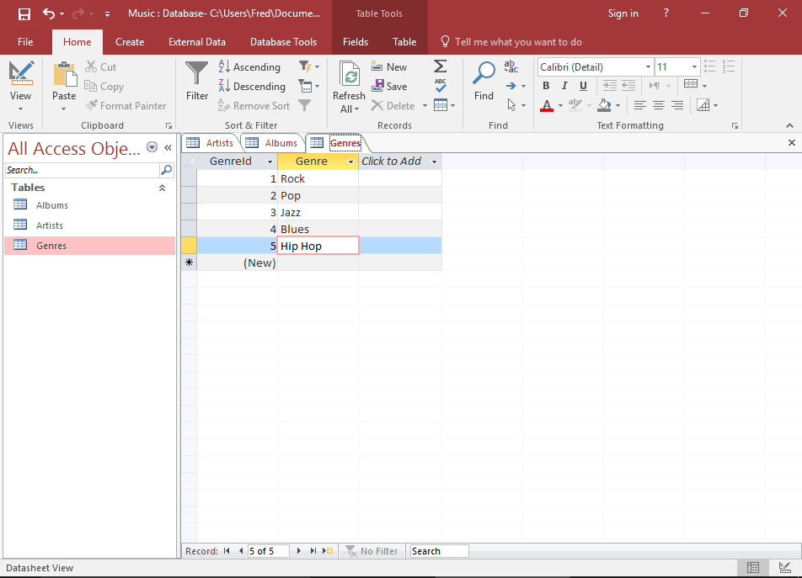

**Add Data using a Form**

In many cases, you will want to create a form for users to enter data. This will allow them to enter data without needing any technical knowledge about Microsoft Access. Forms can also improve usability and increase productivity. They can be used to update data across multiple tables, saving the user from having to open multiple tables and enter data into each one. They can also be use to provide extra data validation.

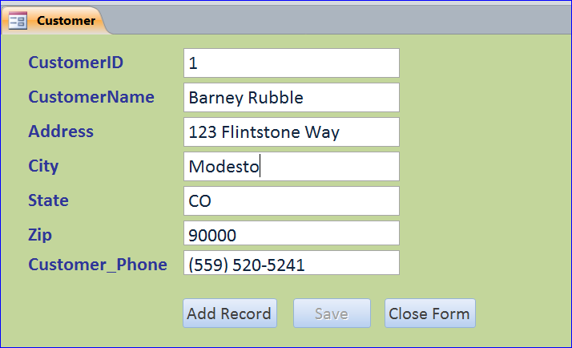

**Add Data using SQL**

SQL (Structured Query Language) is a query language designed specifically for relational databases. Most relational database management systems use SQL. Access uses SQL to carry out the tasks that we specify through the user interface.

An example of an SQL statement to insert data looks like this:



**Import Data from an External Source**

Access provides us with the ability to import data from external sources. Many different data formats are supported, and they can be imported directly to an existing table or a new one can be created based on the source data.

